EAST KENT BABY MEMORIAL GARDENS Autumn 2020
Charity Number 1190080

All Change but No Change!
After seven years as part of Sands, we decided the Ashford Baby Memorial Garden would be better run as a separate charity, and we have now set up the ‘East Kent Baby Memorial Gardens’ charity to manage the Garden from October 2020. We look forward to working closely with East Kent Sands which in future will concentrate on support to families and our local hospitals.

The new charity will make sure the Ashford Baby Memorial Garden continues to be the beautiful lovely place it has always been. We will be able to make sure the Garden stays accessible, that as many people as possible know about it, and that name tiles will continue to be available at a modest cost. We will decide ourselves what activities we undertake and how we use donations, and every penny will be used locally in East Kent.

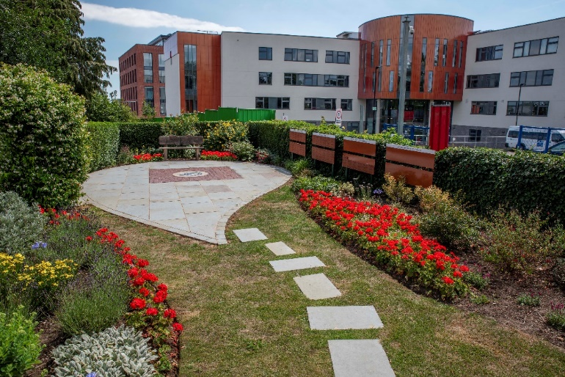
The Team Continues!
The volunteers managing the new charity are Emma Oram (Chair), Vicky Neaves, Sam Miller, Charmaine Price, Christine Twydell, Jo Coles and Chris Twydell, all of whom have been involved with Sands and the Ashford Garden for many years. A big thankyou to them for all they do.

It would be great to have a few more people on board and If anyone else would like to join our small (very friendly!) committee, please get in touch. We would love to have you.

New Web Site
Thanks to Jo for creating and managing our web site www.EastKentBabyMemorialGardens.org.uk and to Ellie for taking some fantastic pictures of the Garden for us. We are excited to announce that on the site we have added the names of each of our special babies www.eastkentbabymemorialgardens.org.uk/our-special-babies Do please tell us if we have made any errors, and if there are other babies you would like mentioned on those pages, let us know. Our new Facebook page is www.facebook.com/EKBMGG Feel free to follow us.

Other Baby Memorial Gardens
Over time, as well as having the Ashford Garden, we want to look at the possibilities of small baby memorial areas in existing community gardens in other parts of East Kent. We also want to work with more local crematoria and cemeteries to help make sure their baby areas are as nice as they can be. Volunteers have already advised Margate Crematorium, and we are hoping to work with the NHS trust to see how the Canterbury Hospital baby area can be made nicer.

Money, money, money!
We have always been proud of the fact that we have been able to raise enough money through fundraising and donations to cover our costs and any other year would have expected to raise around £5k during the summer. But because of Coronavirus, that has not been possible and we have not raised a penny in the last six months! We have, however, still had our core costs including the maintenance contract for the Garden, insurance, storage of equipment, and modest ‘admin’ costs, and we also need to build up a reserve for future years to make sure the Garden is there for ever. At the same time, we don’t want to increase the name tiles costs beyond the current £40.

We have started the new charity with no money at all, and although we have been successful with a couple of grant applications, the future fundraising opportunities remain unclear. We do have enough to keep us going for the coming months, but we do need to build up our money.
If you feel you could make a donation – however small – that would be much appreciated, but please don’t feel under any pressure. Donations can be made direct to our bank (account name ‘East Kent Baby Memorial Gardens Group’, sort code 23-05-80, account number 36580124), via www.justgiving.com/ekbmgc or by post to 13 Goldings Court, Ashford TN24 9JR. Thank you. And do let us know so that we can say ‘thankyou’.

Coronavirus
The pandemic stopped us holding our annual Teddy Bear’s Picnic in July. This is usually a lovely event where families come together with entertainment, fun games, handcraft and, of course, our special memory tree. The pandemic also stopped us from taking part in around thirty fundraising and awareness-raising activities, and realistically, we cannot see us being able to do any of this for the foreseeable future, with the exception of the Lions Santa Collections in December. But looking ahead, if you know of any fetes or fairs or other fundraising opportunities, do, please, let us know.

Baby Loss Awareness Week and the Wave of Light
9-15 October is always Baby Loss Awareness Week and we had arranged an awareness event in Ashford’s County Square. That has had to be cancelled. We would have had our Wave of Light but as that usually attracts over 300 people, clearly that cannot go ahead in its usual format. We have created a programme for a virtual Wave of Light and this is on our website https://www.eastkentbabymemorialgardens.org.uk/family-events Hopefully in 2021 we will once again be able to hold our usual, and very special, event.

During Baby Loss Awareness Week 2020, we are trying to get as many buildings as possible lit up in blue and pink and are grateful to the Grand Hotel in Folkestone and to Whitstable Castle for kindly agreeing to light up their buildings. If you are able to help, perhaps by asking your employer, local church, council building, community centre, shop or anywhere else, that would be really helpful. Do, please, let us know of any successes, and send us a photo, please!

Our Mailing List
We aim to send out a short update like this four times a year. We automatically send these to everyone with a name tile in the Garden, but if you would like to be added to the email list, please let us know, (you can email us at EKBMGG@gmail.com). If you have been sent this by email you are already on our mailing list, but If you do not want further issues, again, please let us know.

Support for You
East Kent Sands will continue to provide support to anyone affected by the death of a baby as well as support to the NHS and can be contacted via eastkentsands@gmail.com Their support contact details are
07547 195 791 (Ashford, Canterbury & Shepway) and 07888 967 463 (Dover, Swale & Thanet).
The Sands National Helpline (0808 164 3332 or helpline@sands.org.uk) also provides a safe, confidential place for anyone who has been affected by the death of a baby and the Sands website www.sands.org.uk has lots of information and links to ways of getting support. Other support organisations are listed on our website https://www.eastkentbabymemorialgardens.org.uk/support-from-other-charities

How you can contact us

- Post: 13 Goldings Court, Ashford, Kent TN24 9JR.
- Phone: 01233 643 976
- Email: EKBMGG@gmail.com
- Website: www.EastKentBabyMemorialGardens.org.uk
- Facebook: www.facebook.com/EKBMGG
- Twitter: https://twitter.com/ekbmgg
- Instagram: @ekbmgg

